CSC Employee Online Training Portal User Manual

# Navigating to the Employee Online Training Portal

1. Open the browser and enter the URL address:

centerforsocialchange.org/cscTraining/csc_training_master_login.php

1. 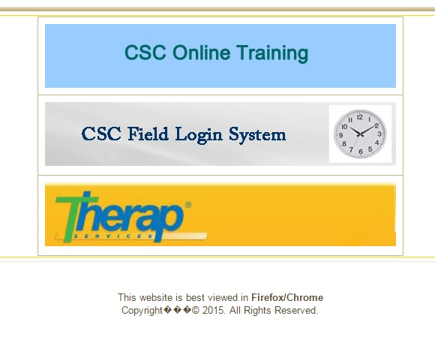Click on the ‘CSC Online Training’ link.

# Logging into the Employee Online Training Portal

1. Enter your CSC issued username
2. Enter your CSC password
3. 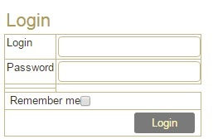Click the ‘Login’ button

# Viewing Your& Staff’s Training Status

1. Click on ‘Staff Training Status’
2. Click on the drop-down menus to search for a staff member by their First or Last Name
3. Alternatively, you can manually type the First or Last Name in the appropriate box
4. Click on the ‘Search’ button

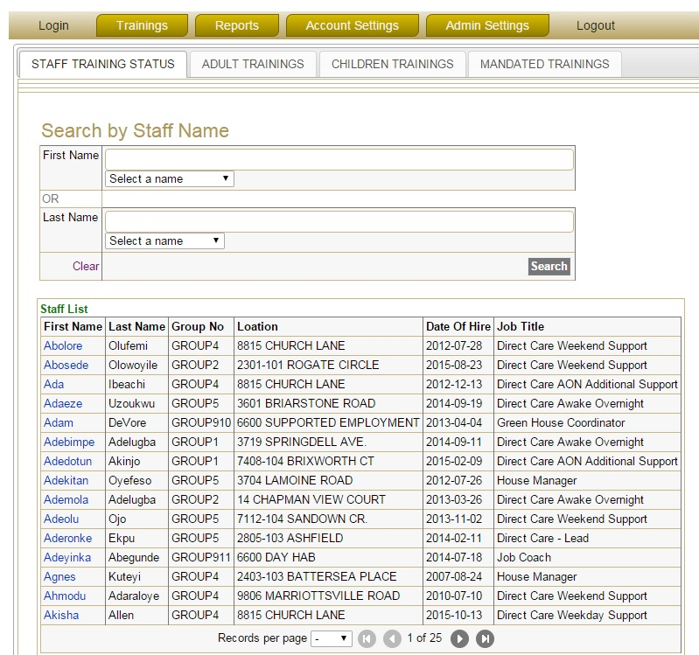

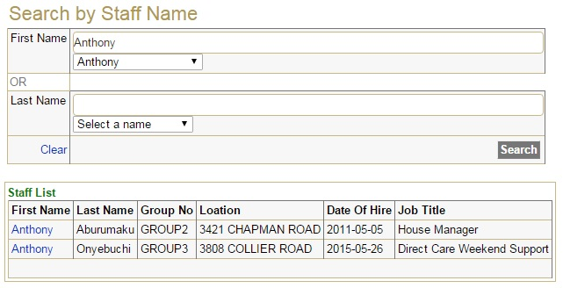

1. Click on the First name of the staff member from the resulting staff list
2. You can now view the trainings of the selected staff ‘s previously attempted

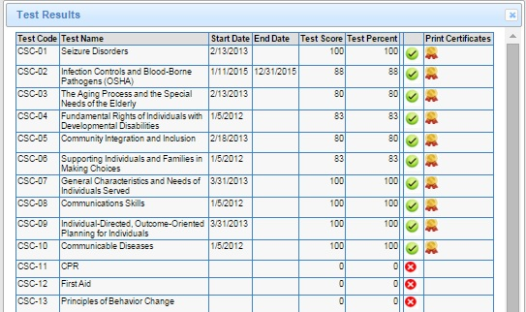

NOTE: The Start Date (date of completion) will only be presented for a Training test that has been passed by the staff member. If he/she has not scored the minimum of 80, the date of completion will remain blank.

NOTE: The End Date (date of expiration) will be the end of the current year. This will only apply to Trainings which have an expiry date.

# Printing Certificates

1. Navigate to specific staff member’s Training Status page
2. Find the specific Training for which you want to print the certificate
3. Click on the  icon in the ‘Print Certificates’ column
4. This will open a new page in PDF file format displaying the certificate for the selected training either to print or save
5. Right-click on the certificate
6. Click on ‘Print’
7. Click on ‘Print’ again. (Ensure the computer is connected and appropriately setup to allow printing of documents)

# Taking or Viewing Available Trainings

1. Place the cursor on the ‘Trainings’ tab
2. Click on ‘Take/View Trainings’ on the drop-down menu

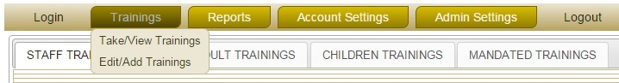

1. Select the appropriate training section by selecting one of the following:
   * Adult Trainings
   * Children Trainings
   * Mandated trainings



1. Find the Training Code & Training Name of the required training from the list below
2. Click on the  icon to the right of the required training to view the associated Study Material
3. Click on the  icon to the right of the required training to take the Online Test

# Taking the Training Online Test

1. Find the Training Code & Training Name of the required training from the list
2. Click on the  icon to the right of the required training to take the Online Test
3. Enter the password given to you
4. 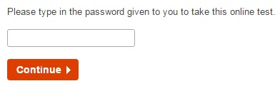Click on the ‘Continue’ button
5. By default your First and Last name will be displayed. If not, please enter your First & Last name in the appropriate boxes
6. 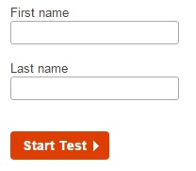Click on ‘Start Test’
7. Select the appropriate answer for each question
8. Click ‘Next’ to view the following questions

NOTE: You cannot view the following questions unless you answer all the questions on the current page.

1. Once you have reached the last question, you can click on the ‘Finish now’ button to submit the test

NOTE: You can view the previous questions by selecting the ‘Display previously viewed questions’ option at the bottom of the page. By clicking on a specific question number, you will be taken to that question.

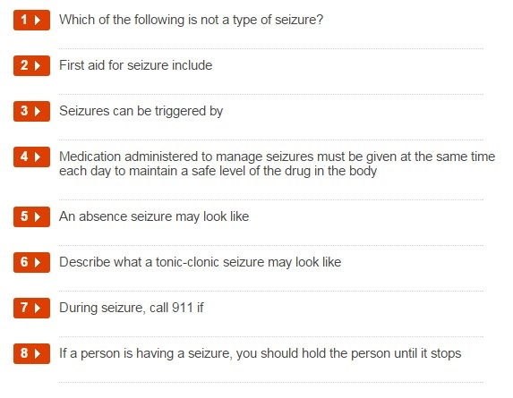

NOTE: The timer at the top of the page tells you how much time you have left before the test will automatically finish.



1. Click ‘Confirm finish now’ to confirm the test submission
2. You will then be told whether your achieved score for the test is a pass or a fail

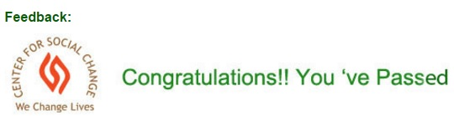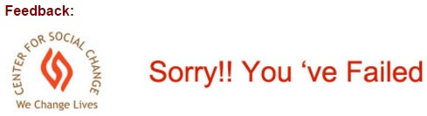

1. Click ‘Show My Results’ to go back to your Training Status page

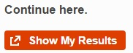

# Editing or Adding Trainings Manually

1. Place the cursor on the ‘Trainings’ tab
2. Click on ‘Edit/Add Trainings’ on the drop-down menu
3. Use the search option to search for staff members by using the drop-down menus or manually entering either the First Name, Last Name or Location in the appropriate box
4. 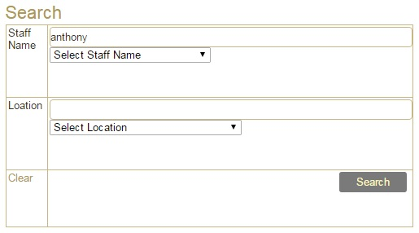Click the ‘Search’ button
5. The staff list will be generated below
6. Click the  button to the left of the required staff member’s name
7. Click on either the Edit Current Trainings or Add Trainings tab at the top of the page



1. To edit the staff member’s trainings, click on the Edit Current Trainings tab. You can then change the Test Start Dates, Test End Date and Scores of Trainings that staff member has already completed. When you are finished, click on ‘Submit’, otherwise click on ‘Cancel’. You will then need to confirm the change by clicking ‘OK’.

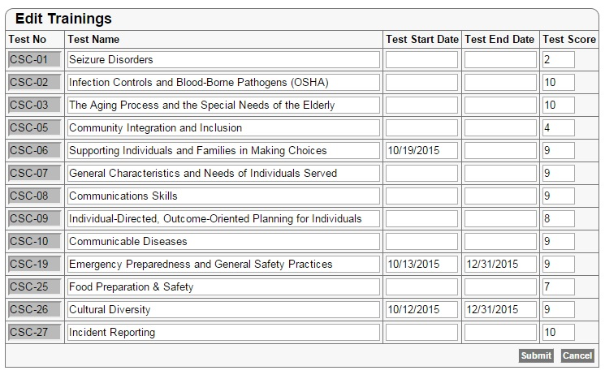

1. To add trainings, click on the Add Trainings tab. You can then select the training by clicking on the appropriate Test No. You can then change Test Score, and add the appropriate Test Start Dates and Test End Date. When you are finished, click on ‘Submit’, otherwise click on ‘Cancel’.

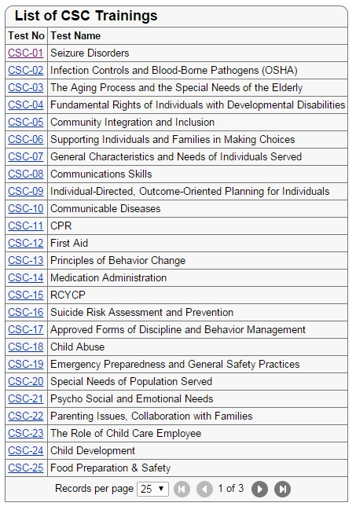

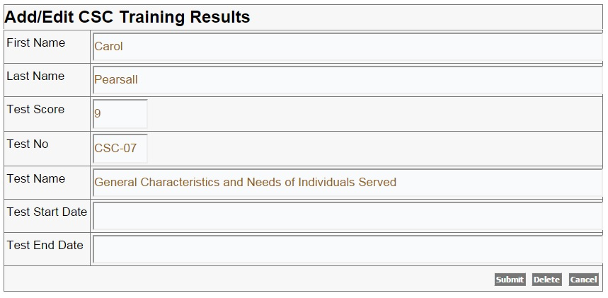

1. When you are done, click on ‘Back to Staff List’

# REPORTS

# Viewing the Staff Training Status by Tests

1. Place the cursor on the ‘Reports’ tab
2. Click on ‘Staff Training Status (by Tests)’ on the drop-down menu
3. 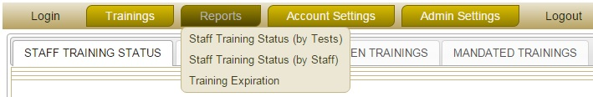Select the required training from the drop-down menu next to ‘Test Name’
4. 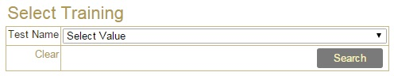Click on ‘Search’
5. The report will be generated for that specific training
6. Click on either ‘Export to PDF’ or ‘Export to Excel’ links placed at the top of the report to export the reports either in PDF file or excel



# Viewing& Printing the Staff Training Status by Staff Name

1. Place the cursor on the ‘Reports’ tab
2. Click on ‘Staff Training Status (by Staff)’ on the drop-down menu
3. An alphabetical list of all staff will be displayed
4. To select a specific staff member and view their trainings, click on their First Name
5. That particular staff member’s training details will be displayed
6. Click on the ‘Printable Version’ link
7. Right-click on the page
8. Click on ‘Print’
9. Click on ‘Print’ again. (Ensure the computer is connected and appropriately setup to allow printing of documents)

# Viewing the Training Expiration

1. Place the cursor on the ‘Reports’ tab
2. Click on ‘Training Expiration’ on the drop-down menu



1. Select the required training from the drop-down menu next to ‘Test Name’
2. Select the Date From
3. Select the Date To
4. 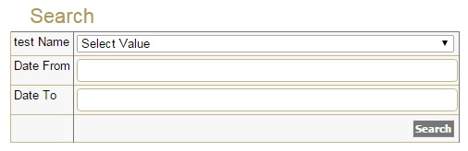Click on the ‘Search’ button
5. The report will be generated for that training during the specified time period
6. Click on either ‘Export to PDF’ or ‘Export to Excel’ above the report to export the report



# Changing Your Password

1. Place the cursor on the ‘Account Settings’ tab
2. Click on ‘Change My Password’ on the drop-down menu

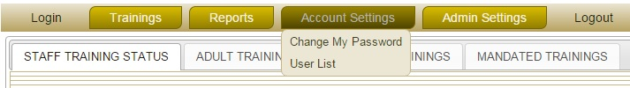

1. Your details will be displayed
2. Click on your First Name
3. Enter your new password in the text box nest to ‘New Password’
4. Confirm your new password by entering it in the text box nest to ‘Confirm Password’
5. 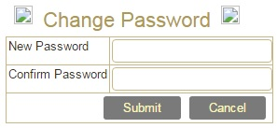Click on ‘Submit’ to confirm the change, or ‘Cancel’ to cancel it

NOTE: A user can change his/her password at any time using this feature.

# Viewing the User List

1. Place the cursor on the ‘Account Settings’ tab
2. Click on ‘User List’ on the drop-down menu
3. A list of all staff and their details will be displayed

# ADMIN SETTINGS

NOTE: All settings under this module are only available to the super administrators.

# Resetting Staff Passwords of users

1. 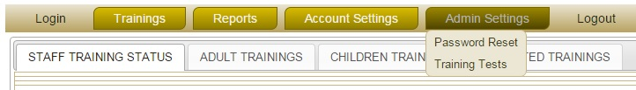Place the cursor on the ‘Admin Settings’ tab
2. Click on ‘Password Reset’ on the drop-down menu
3. Select the staff member, either from the drop-down meu or by manually searching through the pages.
4. Click on the staff member’s First Name
5. Enter the new password in the text box nest to ‘New Password’
6. Confirm the new password by entering it in the text box nest to ‘Confirm Password’
7. Click on ‘Submit’ to confirm the change, or ‘Cancel’ to cancel it

# Editing Training Tests

1. Place the cursor on the ‘Admin Settings’ tab
2. Click on ‘Training Tests’ on the drop-down menu
3. A list of all Training tests with their details will be displayed
4. Click on the ‘Id’ number to the left of the Test Code to edit it
5. You can now edit any details for that particular test
6. Click on ‘Submit’ to confirm the change, or ‘Delete’ to delete the Training test, or click ‘Cancel’ to cancel any changes

# Logging Out

1. To logout from the online training portal, click on the ‘Logout’ button.
2. Confirm the logout by clicking on the ‘Logout’ link again.



**For HR Department Users only**

Employees Enrolment on CSCHRM software

* 1. Click add button under PIM Module

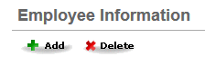

* 1. Enter first and last name of new employee and click ‘Save’ button

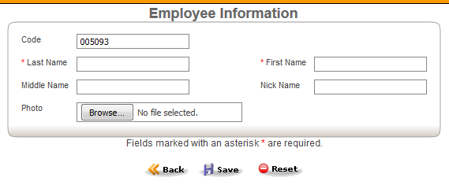

* 1. Fill the following details under the ‘Job’ Module

1. Job title
2. Location
3. Joined Date
4. Employment Status

Selection of Employment Status

|  |  |  |
| --- | --- | --- |
|  | Nature of employment | Employment Status |
| 1 | Regular employee | Full time permanent |
| 2 | Employee under recruitment process | Emp_Progress |
| 3 | Administrative staffs – as user to training software | *CSCHRM-Training User |
| 4 | Administrative Staffs – as Supervisor to training software | **CSCHRM – Training Supervisor |
| 5 | Administrative Staffs – as Manager to training Software | ***CSCHRM – Training Manager |
| 6 | OPEN positions | Full Time Contract |

* No access to Printing certificates, Reports and Settings

** No access to Reports and settings

*** Full access except admin settings

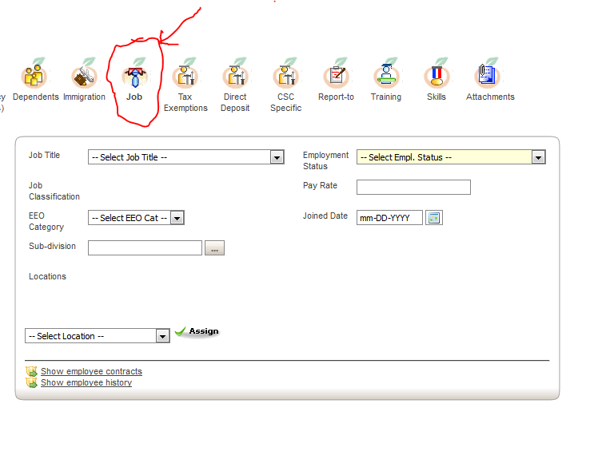

Scheduling Employees for online training from CSCHRM

The data transfer of employees details from CSCHRM to training software application are scheduled four times a day temporarily. So please make sure to enter the new employee details on CSCHRM at least one day before the new staff scheduled to take the trainings. This is only a temporary adjustment and the real time transfer will be enabled after evaluating data traffic between the hosted servers.