CSC Employee Online Training Portal User Manual

# Navigating to the Employee Online Training Portal

1. Open the browser and enter the URL address:

centerforsocialchange.org/cscTraining/csc_training_master_login.php

1. 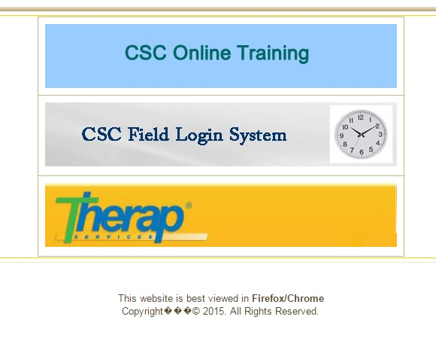Click on the ‘CSC Online Training’ link.

# Logging into the Employee Online Training Portal

1. Enter your CSC issued username
2. Enter your CSC password
3. 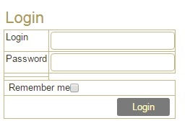Click the ‘Login’ button

# Viewing Your Training Status

1. Click on ‘My Training Status’
2. 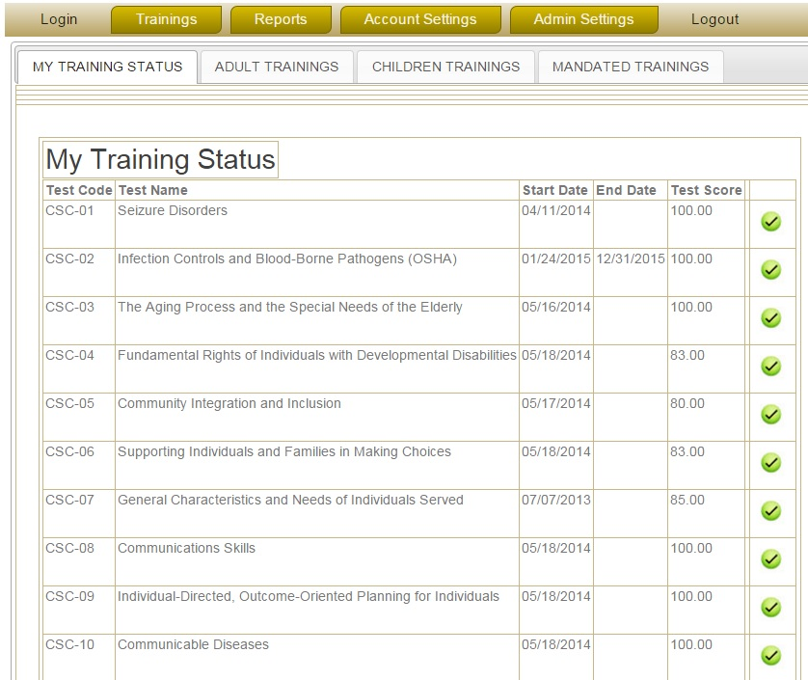You can now view the trainings you have previously attempted and the score you received for them

NOTE: The Start Date (date of completion) will only be presented for a Training test that has been passed by the staff member. If he/she has not scored the minimum of 80, the date of completion will remain blank.

NOTE: The End Date (date of expiration) will be the end of the current year. This will only apply to Trainings which have an expiry date.

# Taking or Viewing Available Trainings

1. Place the cursor on the ‘Trainings’ tab
2. Click on ‘Take/View Trainings’ on the drop-down menu

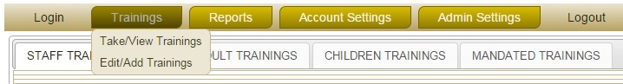

1. Select the appropriate training section by selecting one of the following:
   * Adult Trainings
   * Children Trainings
   * Mandated trainings



1. Find the Training Code & Training Name of the required training from the list below
2. Click on the  button to the right of the required training to view the associated Study Material
3. Click on the  button to the right of the required training to take the Online Test

# Taking the Training Online Test

1. Find the Training Code & Training Name of the required training from the list
2. Click on the  button to the right of the required training to take the Online Test
3. Enter the password given to you
4. 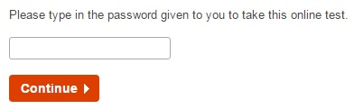Click on the ‘Continue’ button
5. By default your First and Last name will be displayed. If not, please enter your First & Last name in the appropriate boxes
6. 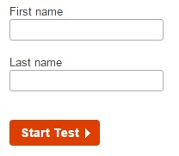Click on ‘Start Test’
7. Select the appropriate answer for each question
8. Click ‘Next’ to view the following questions

NOTE: You cannot view the following questions unless you answer all the questions on the current page.

1. Once you have reached the last question, you can click on the ‘Finish now’ button to submit the test

NOTE: You can view the previous questions by selecting the ‘Display previously viewed questions’ option at the bottom of the page. By clicking on a specific question number, you will be taken to that question.

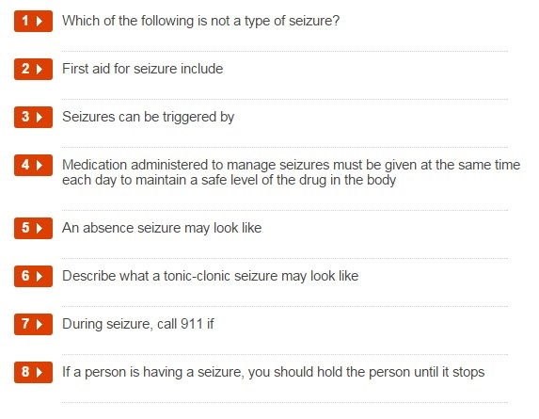

NOTE: The timer at the top of the page tells you how much time you have left before the test will automatically finish.



1. Click ‘Confirm finish now’ to confirm the test submission
2. You will then be told whether your achieved score for the test is a pass or a fail

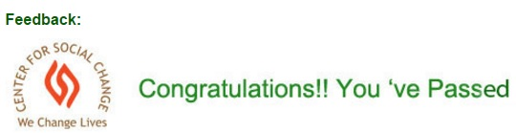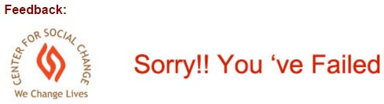

1. Click ‘Show My Results’ to go back to your Training Status page

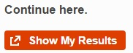

# Changing Your Password

1. Place the cursor on the ‘Account Settings’ tab
2. Click on ‘Change My Password’ on the drop-down menu

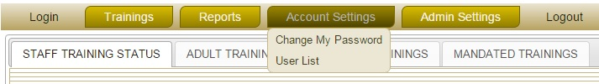

1. Your details will be displayed
2. Click on your First Name
3. Enter your new password in the text box nest to ‘New Password’
4. Confirm your new password by entering it in the text box nest to ‘Confirm Password’
5. Click on ‘Submit’ to confirm the change, or ‘Cancel’ to cancel it

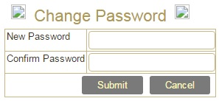

NOTE: A user can change his/her password at any time using this feature.

# Logging Out

1. To logout from the online training portal, click on the ‘Logout’ button.
2. Confirm the logout by clicking on the ‘Logout’ link again.

